Login to Jenkins
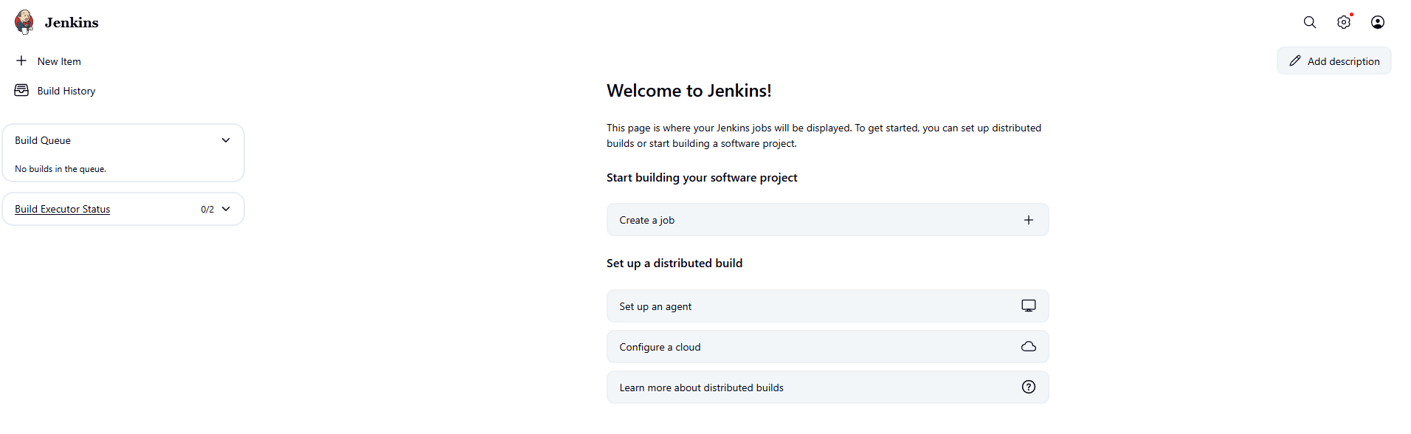
Click new item
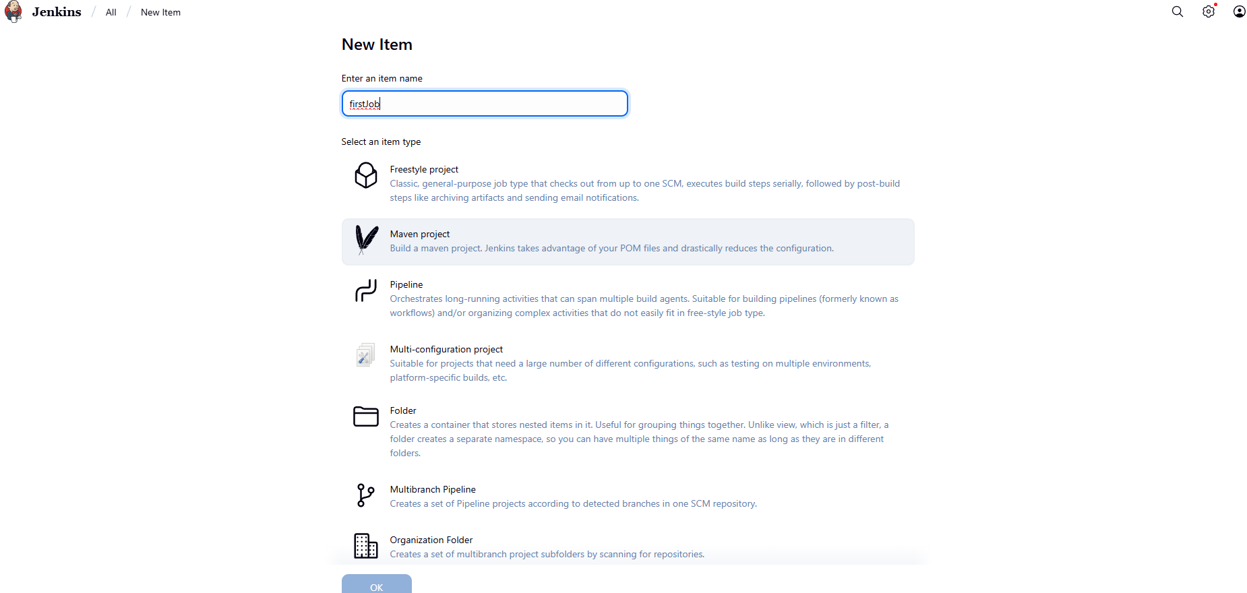
Setup your job now
- Source code management – specify repo and branch details to pull code
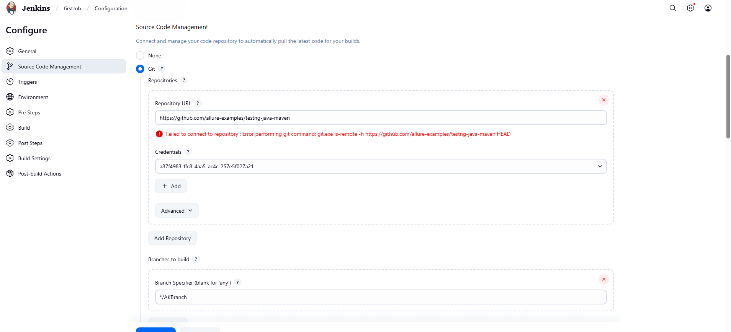
2.Build triggers
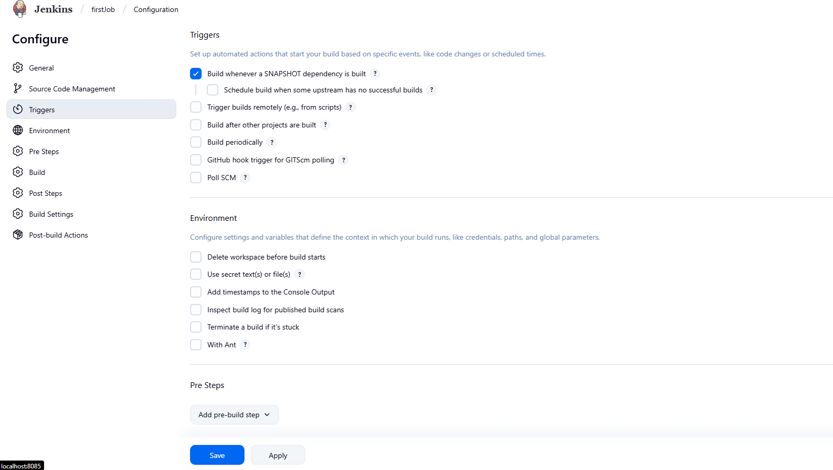

chrono expression – expression to specify how often to auto-trigger the job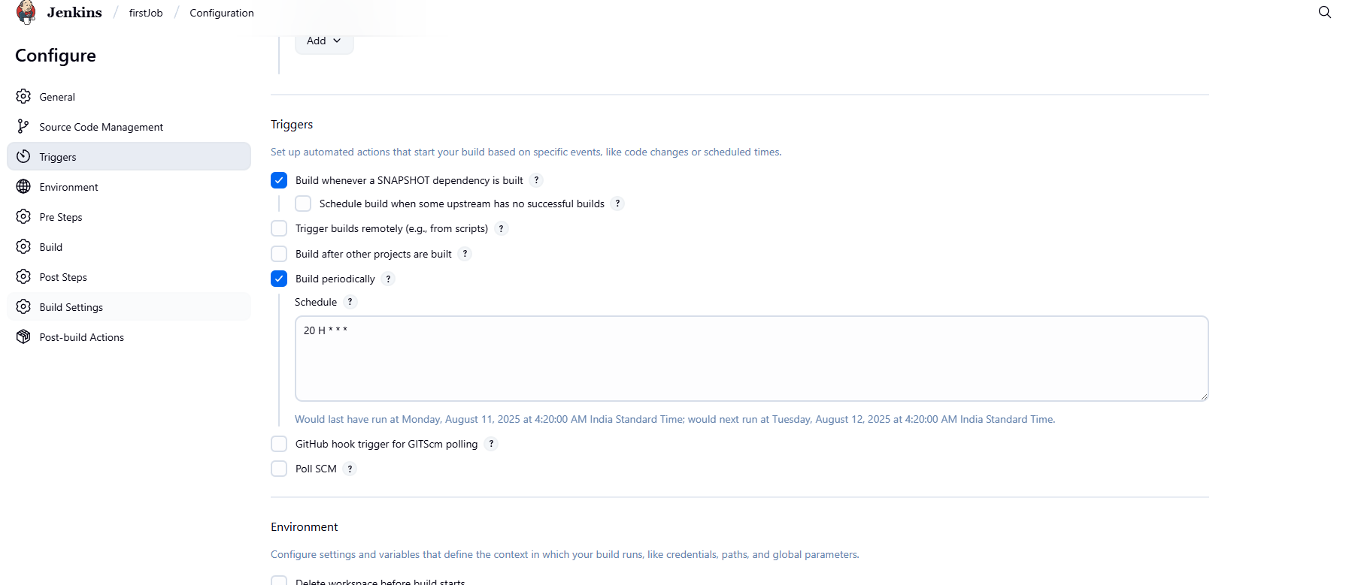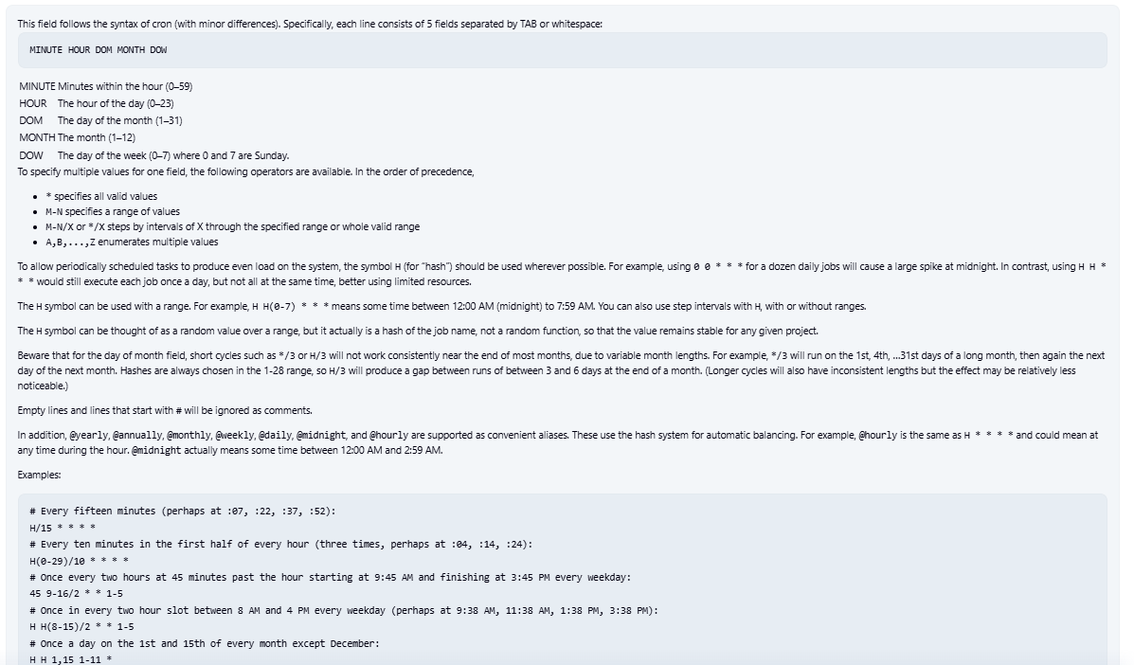
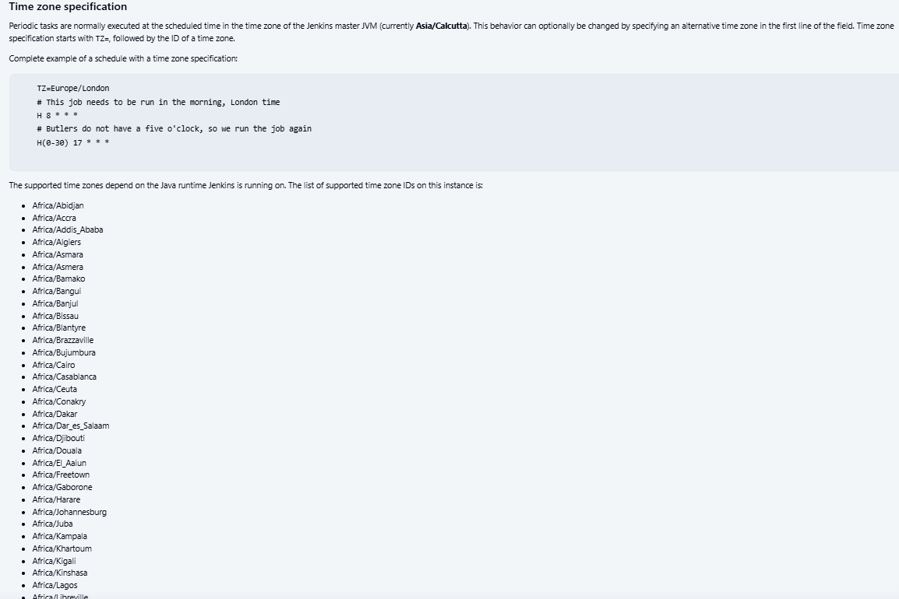In Jenkins, Poll SCM is an option within the Source Code Management (SCM) section that allows you to schedule automated builds based on changes in your code repository. It periodically checks for new commits or modifications in your repository and, if found, triggers a build. This helps facilitate continuous integration and automated testing by providing quick feedback to developers about the impact of their changes

Setup Pre-build steps(setting up docker images, building docker ctrs)
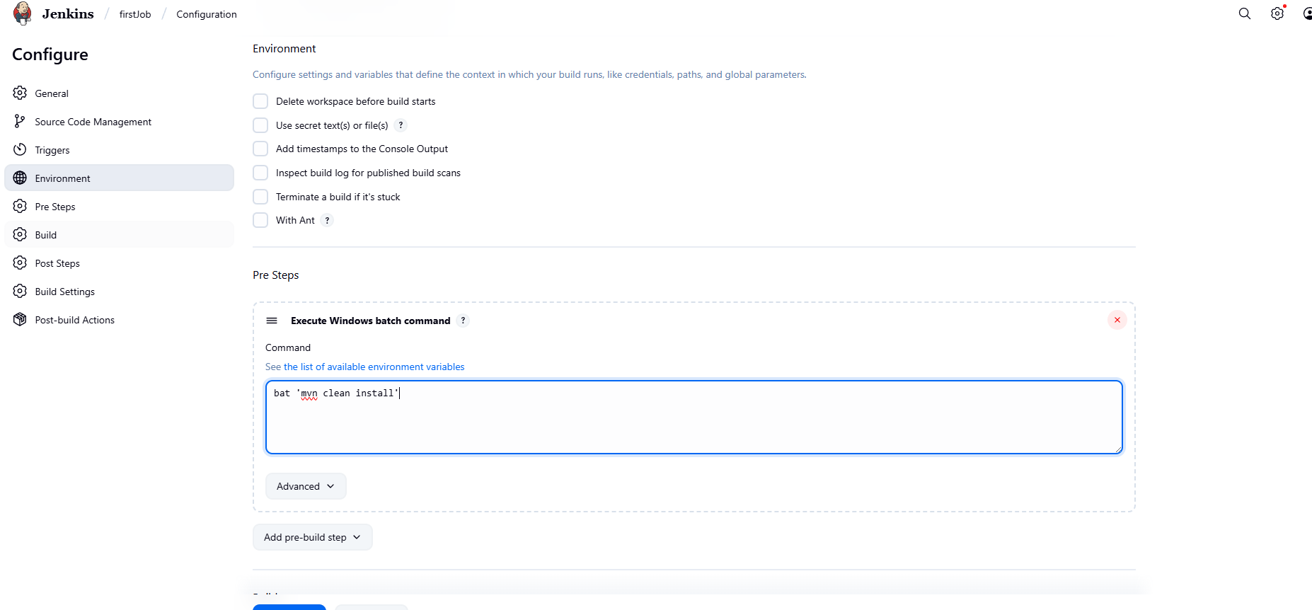
Setup maven configurations and goals(maven clean, maven build, etc.)
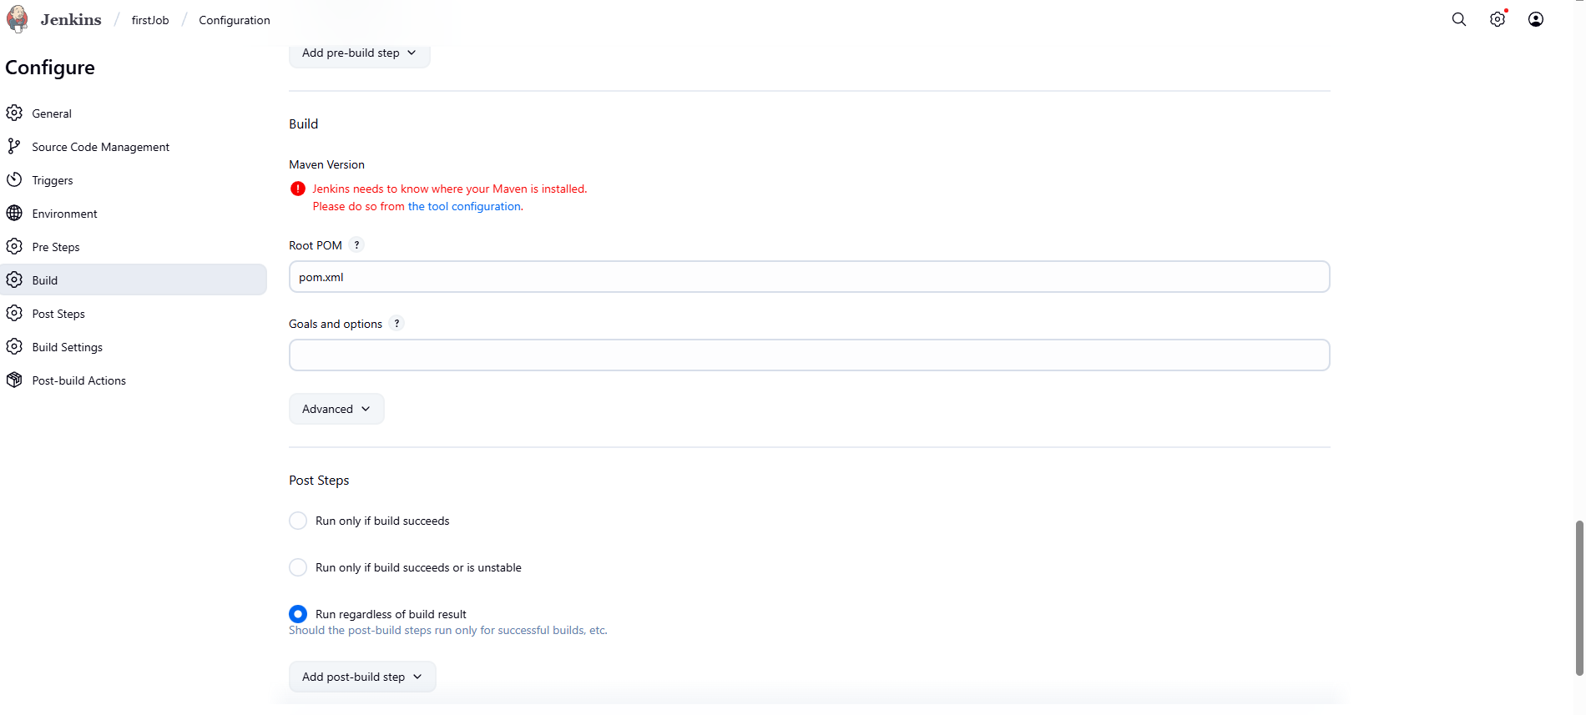

Setup Post build actions(sharing and generating reports)
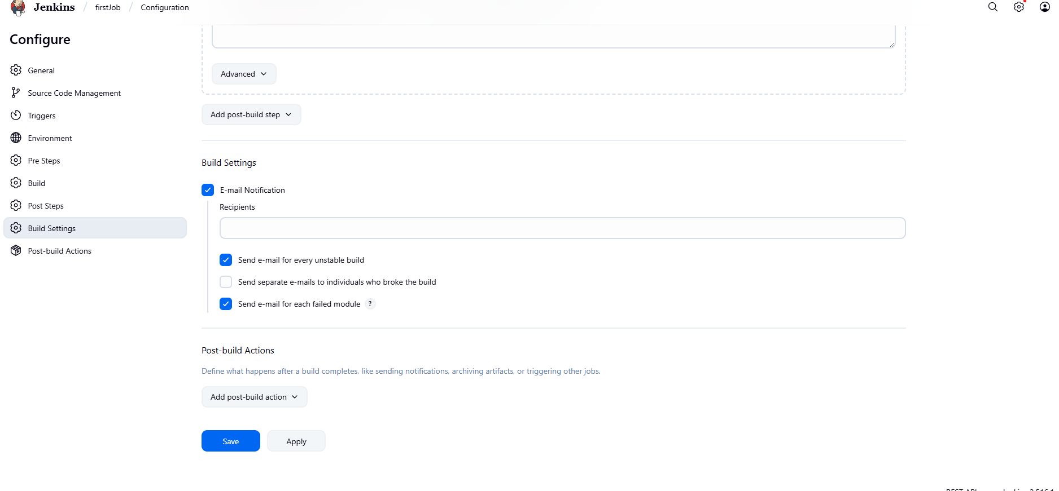

Save and Build Project